JSF - Page Navigation

Navigation rules are those rules provided by JSF Framework which describe which view is to be shown when a button or link is clicked.
- Navigation rules can be defined in JSF configuration file named faces-config.xml.
- Navigation rules can be defined in managed beans.
- Navigation rules can contain conditions based on which resulted view can be shown.
- JSF 2.0 provides implicit navigation as well in which there is no need to define navigation rules as such.

Implicit Navigation

JSF 2.0 provides auto view page resolver mechanism named implicit navigation. In this case you only need to put view name in action attribute and JSF will search the correct view page automatically in the deployed application.
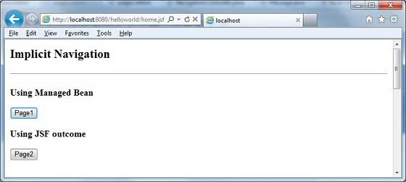

Auto navigation in JSF page

Set view name in action attribute of any JSF UI Component.
<h:form>
<h3>Using JSF outcome</h3>
<h:commandButton action="page2" value="Page2" />
</h:form>
Here when Page2 button is clicked, JSF will resolve the view name, page2 as page2.xhtml extension, and find the corresponding view file page2.xhtml in the current directory.
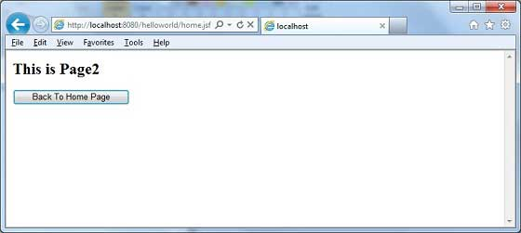

Auto navigation in Managed Bean
Define a method in managed bean to return a view name.
@ManagedBean(name = "navigationController", eager = true)
@RequestScoped
public class NavigationController implements Serializable {
public String moveToPage1(){
return "page1";
}
}
Get view name in action attribute of any JSF UI Component using managed bean.
<h:form>
<h3>Using Managed Bean</h3>
<h:commandButton action="#{navigationController.moveToPage1}"
value="Page1" />
</h:form>
Here when Page1 button is clicked, JSF will resolve the view name, page1 as page1.xhtml extension, and find the corresponding view file page1.xhtml in the current directory.
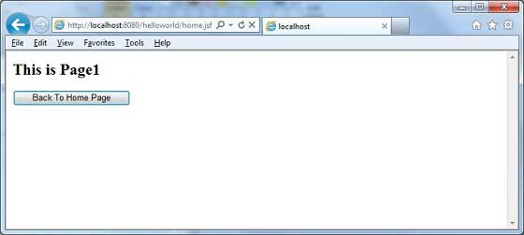

Conditional Navigation
Using managed bean we can very easily control the navigation. Look at following code in a managed bean.
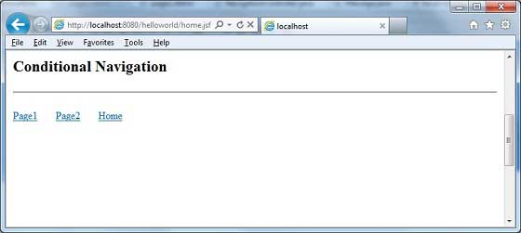
@ManagedBean(name = "navigationController", eager = true)
@RequestScoped
public class NavigationController implements Serializable {

//this managed property will read value from request parameter pageId
@ManagedProperty(value="#{param.pageId}")
private String pageId;

//condional navigation based on pageId
//if pageId is 1 show page1.xhtml,
//if pageId is 2 show page2.xhtml
//else show home.xhtml
public String showPage(){
if(pageId == null){
return "home";
}
if(pageId.equals("1")){
return "page1";
}else if(pageId.equals("2")){
return "page2";
}else{
return "home";
}
}
}
Pass pageId as a request parameter in JSF UI Component.
<h:form>
<h:commandLink action="#{navigationController.showPage}" value="Page1">
<f:param name="pageId" value="1" />
</h:commandLink>
<h:commandLink action="#{navigationController.showPage}" value="Page2">
<f:param name="pageId" value="2" />
</h:commandLink>
<h:commandLink action="#{navigationController.showPage}" value="Home">
<f:param name="pageId" value="3" />
</h:commandLink>
</h:form>
Here when "Page1" button is clicked
- JSF will create a request with parameter pageId=1
- Then JSF will pass this parameter to managed property pageId of navigationController
- Now navigationController.showPage() is called which will return view as page1 after checking the pageId
- JSF will resolve the view name, page1 as page1.xhtml extension
- and find the corresponding view file page1.xhtml in the current directory

Resolving Navigation based on from-action

JSF provides navigation resolution option even if managed bean different methods returns same view name.
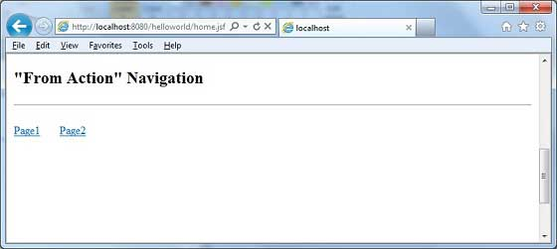
Look at following code in a managed bean.
public String processPage1(){
return "page";
}
public String processPage2(){
return "page";
}
To resolve views, define following navigation rule in faces-config.xml
<navigation-rule>
<from-view-id>home.xhtml</from-view-id>
<navigation-case>
<from-action>#{navigationController.processPage1}</from-action>
<from-outcome>page</from-outcome>
<to-view-id>page1.jsf</to-view-id>
</navigation-case>
<navigation-case>
<from-action>#{navigationController.processPage2}</from-action>
<from-outcome>page</from-outcome>
<to-view-id>page2.jsf</to-view-id>
</navigation-case>
</navigation-rule>
Here when Page1 button is clicked
- navigationController.processPage1() is called which will return view as page
- JSF will resolve the view name, page1 as view name is page and from-action in faces-config is navigationController.processPage1
- and find the corresponding view file page1.xhtml in the current directory

Forward vs Redirect
JSF by default performs a server page forward while navigating to another page and the URL of the application do not changes.
To enable the page redirection, append faces-redirect=true at the end of the view name.
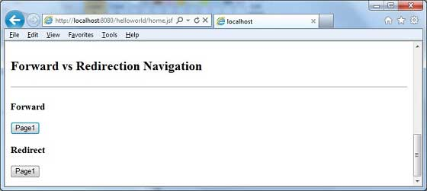
<h:form>
<h3>Forward</h3>
<h:commandButton action="page1" value="Page1" />
<h3>Redirect</h3>
<h:commandButton action="page1?faces-redirect=true" value="Page1" />
</h:form>
Here when Page1 button under Forward is clicked
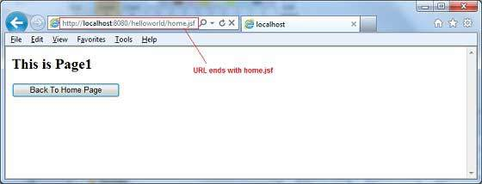
Here when Page1 button under Redirect is clicked
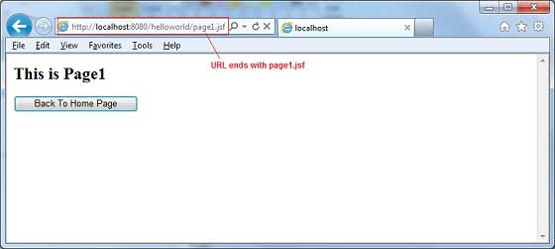

Example Application
Let us create a test JSF application to test all of the above navigation examples.
Step | Description
1 | Create a project with a name helloworld under a package com.tutorialspoint.test as explained in the JSF - Create Application chapter.
2 | Create NavigationController.java under a package com.tutorialspoint.test as explained below.
3 | Create faces-config.xml under a WEB-INF folder and updated its contents as explained below.
4 | Update web.xml under a WEB-INF folder as explained below.
5 | Create page1.xhtml and page2.xhtml and modify home.xhtml under a webapp folder as explained below.
6 | Compile and run the application to make sure business logic is working as per the requirements.
7 | Finally, build the application in the form of war file and deploy it in Apache Tomcat Webserver.
8 | Launch your web application using appropriate URL as explained below in the last step.

NavigationController.java
package com.tutorialspoint.test;

import java.io.Serializable;

import javax.faces.bean.ManagedBean;
import javax.faces.bean.ManagedProperty;
import javax.faces.bean.RequestScoped;

@ManagedBean(name = "navigationController", eager = true)
@RequestScoped
public class NavigationController implements Serializable {

private static final long serialVersionUID = 1L;

@ManagedProperty(value="#{param.pageId}")
private String pageId;

public String moveToPage1(){
return "page1";
}

public String moveToPage2(){
return "page2";
}

public String moveToHomePage(){
return "home";
}

public String processPage1(){
return "page";
}

public String processPage2(){
return "page";
}

public String showPage(){
if(pageId == null){
return "home";
}
if(pageId.equals("1")){
return "page1";
}else if(pageId.equals("2")){
return "page2";
}else{
return "home";
}
}

public String getPageId() {
return pageId;
}

public void setPageId(String pageId) {
this.pageId = pageId;
}
}

faces-config.xml
<?xml version="1.0" encoding="UTF-8"?>
<faces-config
xmlns="http://java.sun.com/xml/ns/javaee"
xmlns:xsi="http://www.w3.org/2001/XMLSchema-instance"
xsi:schemaLocation="http://java.sun.com/xml/ns/javaee
http://java.sun.com/xml/ns/javaee/web-facesconfig_2_0.xsd"
version="2.0">
<navigation-rule>
<from-view-id>home.xhtml</from-view-id>
<navigation-case>
<from-action>#{navigationController.processPage1}</from-action>
<from-outcome>page</from-outcome>
<to-view-id>page1.jsf</to-view-id>
</navigation-case>
<navigation-case>
<from-action>#{navigationController.processPage2}</from-action>
<from-outcome>page</from-outcome>
<to-view-id>page2.jsf</to-view-id>
</navigation-case>
</navigation-rule>
</faces-config>

web.xml
<!DOCTYPE web-app PUBLIC
"-//Sun Microsystems, Inc.//DTD Web Application 2.3//EN"
"http://java.sun.com/dtd/web-app_2_3.dtd" >

<web-app>
<display-name>Archetype Created Web Application</display-name>

<context-param>
<param-name>javax.faces.PROJECT_STAGE</param-name>
<param-value>Development</param-value>
</context-param>
<context-param>
<param-name>javax.faces.CONFIG_FILES</param-name>
<param-value>/WEB-INF/faces-config.xml</param-value>
</context-param>
<servlet>
<servlet-name>Faces Servlet</servlet-name>
<servlet-class>javax.faces.webapp.FacesServlet</servlet-class>
</servlet>
<servlet-mapping>
<servlet-name>Faces Servlet</servlet-name>
<url-pattern>*.jsf</url-pattern>
</servlet-mapping>
</web-app>

page1.xhtml
<?xml version="1.0" encoding="UTF-8"?>
<!DOCTYPE html PUBLIC "-//W3C//DTD XHTML 1.0 Transitional//EN"
"http://www.w3.org/TR/xhtml1/DTD/xhtml1-transitional.dtd">
<html xmlns="http://www.w3.org/1999/xhtml"
xmlns:h="http://java.sun.com/jsf/html">
<h:body>
<h2>This is Page1</h2>
<h:form>
<h:commandButton action="home?faces-redirect=true"
value="Back To Home Page" />
</h:form>
</h:body>
</html>

page2.xhtml
<?xml version="1.0" encoding="UTF-8"?>
<!DOCTYPE html PUBLIC "-//W3C//DTD XHTML 1.0 Transitional//EN"
"http://www.w3.org/TR/xhtml1/DTD/xhtml1-transitional.dtd">
<html xmlns="http://www.w3.org/1999/xhtml"
xmlns:h="http://java.sun.com/jsf/html">
<h:body>
<h2>This is Page2</h2>
<h:form>
<h:commandButton action="home?faces-redirect=true"
value="Back To Home Page" />
</h:form>
</h:body>
</html>

home.xhtml
<?xml version="1.0" encoding="UTF-8"?>
<!DOCTYPE html PUBLIC "-//W3C//DTD XHTML 1.0 Transitional//EN"
"http://www.w3.org/TR/xhtml1/DTD/xhtml1-transitional.dtd">
<html xmlns="http://www.w3.org/1999/xhtml"
xmlns:f="http://java.sun.com/jsf/core"
xmlns:h="http://java.sun.com/jsf/html">

<h:body>
<h2>Implicit Navigation</h2>
<hr />
<h:form>
<h3>Using Managed Bean</h3>
<h:commandButton action="#{navigationController.moveToPage1}"
value="Page1" />
<h3>Using JSF outcome</h3>
<h:commandButton action="page2" value="Page2" />
</h:form>
<br/>
<h2>Conditional Navigation</h2>
<hr />
<h:form>
<h:commandLink action="#{navigationController.showPage}"
value="Page1">
<f:param name="pageId" value="1" />
</h:commandLink>

<h:commandLink action="#{navigationController.showPage}"
value="Page2">
<f:param name="pageId" value="2" />
</h:commandLink>

<h:commandLink action="#{navigationController.showPage}"
value="Home">
<f:param name="pageId" value="3" />
</h:commandLink>
</h:form>
<br/>
<h2>"From Action" Navigation</h2>
<hr />
<h:form>
<h:commandLink action="#{navigationController.processPage1}"
value="Page1" />

<h:commandLink action="#{navigationController.processPage2}"
value="Page2" />

</h:form>
<br/>
<h2>Forward vs Redirection Navigation</h2>
<hr />
<h:form>
<h3>Forward</h3>
<h:commandButton action="page1" value="Page1" />
<h3>Redirect</h3>
<h:commandButton action="page1?faces-redirect=true"
value="Page1" />
</h:form>
</h:body>
</html>
Once you are ready with all the changes done, let us compile and run the application as we did in JSF - Create Application chapter. If everything is fine with your application, this will produce following result:
